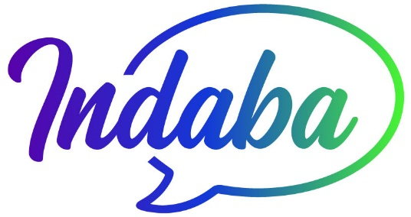

Fundamentals of Race and Racism: A Foundation for Unified Action
Workshop Registration - April 26 & 27, 2025 10am to 4pm

Name: Organization Title

Email: Phone:

Address

City State Zip

What do you hope to gain from participating in this workshop?

Are you currently or have you previously explored this topic? If so please describe briefly.

How do you identify racially?

How did you learn about this workshop?

Registration fee is $300. Completion of this form and payment will secure your seat in the workshop. Please make checks out to Indaba Action Team and mail to PO Box 4060 Madison, CT or request electronic option. This form can be mailed with payment or emailed to indabaactionteam@gmail.com

If requesting a scholarship, how much are you requesting toward the registration fee?

